SALES ANALYSIS QUERIES
SQL QUERIES
DATA CLEANING AND VALIDATION
Check Null Values in Each Column

SELECT
SUM(CASE WHEN State IS NULL THEN 1 ELSE 0 END) AS null_state,
SUM(CASE WHEN City IS NULL THEN 1 ELSE 0 END) AS null_city,
SUM(CASE WHEN Order_Date IS NULL THEN 1 ELSE 0 END) AS null_order_date,
SUM(CASE WHEN Restaurant_Name IS NULL THEN 1 ELSE 0 END) AS null_restauant_name,
SUM(CASE WHEN Location IS NULL THEN 1 ELSE 0 END) AS null_location,
SUM(CASE WHEN Category IS NULL THEN 1 ELSE 0 END) AS null_category,
SUM(CASE WHEN Dish_Name IS NULL THEN 1 ELSE 0 END) AS null_dish_name,
SUM(CASE WHEN Price_INR IS NULL THEN 1 ELSE 0 END) AS null_price_inr,
SUM(CASE WHEN Rating IS NULL THEN 1 ELSE 0 END) AS null_rating,
SUM(CASE WHEN Rating_Count IS NULL THEN 1 ELSE 0 END) AS null_rating_count
FROM swiggy_data
Blank/Empty String Check
SELECT *
FROM swiggy_data
WHERE State = '' OR City = '' OR Restaurant_Name = '' OR Location = '' OR Category = '' OR Dish_Name = '';
Duplicate detection
SELECT state, city, order_date, restaurant_name, location, category, dish_name, price_inr, rating, rating_COUNT, COUNT(*) AS CNT
FROM swiggy_data
GROUP BY state, city, order_date, restaurant_name, location, category, dish_name, price_inr, rating, rating_COUNT
HAVING COUNT(*) > 1
Remove Duplicates
WITH CTE AS(
SELECT *, ROW_NUMBER() OVER(
PARTITION BY city, order_date, restaurant_name, location, category, dish_name, price_inr, rating, rating_COUNT
ORDER BY (SELECT NULL)
) AS rn
FROM swiggy_data
)
DELETE FROM CTE WHERE rn > 1
Dimensional Modelling (Star Schema)
--CREATING A SCHEMA
--DIMENSION TABLE
--DATE TABLE
CREATE TABLE dim_date (
date_id INT IDENTITY(1,1) PRIMARY KEY,
Full_Date DATE,
Year INT,
Month INT,
Month_Name VARCHAR(20),
Quarter INT,
Day INT,
Week INT
);

--LOCATION TABLE
CREATE TABLE dim_location (
location_id INT IDENTITY(1,1) PRIMARY KEY,
State VARCHAR(100),
City VARCHAR(100),
Location VARCHAR(200)
);

--RESTAURANT TABLE
CREATE TABLE dim_restaurant (
restaurant_id INT IDENTITY(1,1) PRIMARY KEY,
Restaurant_Name VARCHAR(200)
);

--CATEGORY TABLE
CREATE TABLE dim_category (
category_id INT IDENTITY(1,1) PRIMARY KEY,
category VARCHAR(200)
);

--DISH TABLE
CREATE TABLE dim_dish (
dish_id INT IDENTITY(1,1) PRIMARY KEY,
Dish_Name VARCHAR(200)
);

Creating Fact Table
CREATE TABLE fact_swiggy_orders (
order_id INT IDENTITY(1,1) PRIMARY KEY,

date_id INT,
Price_INR DECIMAL(10,2),
Rating DECIMAL(4,2),
Rating_COUNT INT,

location_id INT,
restaurant_id INT,
category_id INT,
dish_id INT,

FOREIGN KEY (date_id) REFERENCES dim_date(date_id),
FOREIGN KEY (location_id) REFERENCES dim_location(location_id),
FOREIGN KEY (restaurant_id) REFERENCES dim_restaurant(restaurant_id),
FOREIGN KEY (category_id) REFERENCES dim_category(category_id),
FOREIGN KEY (dish_id) REFERENCES dim_dish(dish_id)
);

Inserting Data In All Tables
Date table
INSERT INTO dim_date (Full_Date, Year, Month, Month_Name, Quarter, Week, Day)
SELECT DISTINCT
Order_Date,
YEAR(Order_Date),
MONTH(Order_Date),
DATENAME(MONTH, Order_Date),
DATEPART(QUARTER, Order_Date),
DAY(Order_Date),
DATEPART(WEEK, Order_Date)
FROM swiggy_data
WHERE Order_Date IS NOT NULL;

Location Table
INSERT INTO dim_location (State, City, Location)
SELECT DISTINCT
State,
City,
Location
FROM swiggy_data;
Restaurant Table
INSERT INTO dim_restaurant (Restaurant_Name)
SELECT DISTINCT
Restaurant_Name
FROM swiggy_data;

Category Table
INSERT INTO dim_category (Category)
SELECT DISTINCT
Category
FROM swiggy_data;

Dish Table
INSERT INTO dim_dish (Dish_Name)
SELECT DISTINCT
Dish_Name
FROM swiggy_data;
INSERT INTO FACT TABLE
INSERT INTO fact_swiggy_orders
(
date_id,
price_INR,
Rating,
Rating_Count,
location_id,
restaurant_id,
category_id,
dish_id
)
SELECT

dd.date_id,
s.price_INR,
s.Rating,
s.Rating_Count,

dl.location_id,
dr.restaurant_id,
dc.category_id,
dsh.dish_id
FROM swiggy_data s

JOIN dim_date dd
ON dd.Full_Date = s.Order_Date

JOIN dim_location dl
ON dl.State = s.State
AND dl.City = s.City
AND dl.Location = s.Location

JOIN dim_restaurant dr
ON dr.Restaurant_Name = s.Restaurant_Name

JOIN dim_category dc
ON dc.Category = s.Category

JOIN dim_dish dsh
ON dsh.Dish_Name = s.Dish_Name;

SELECT * FROM fact_swiggy_orders f
JOIN dim_date d ON f.date_id = d.date_id
JOIN dim_location l ON f.location_id = l.location_id
JOIN dim_restaurant r ON f.restaurant_id = r.restaurant_id
JOIN dim_category c ON f.category_id = c.category_id
JOIN dim_dish di ON f.dish_id = di.dish_id

BUSINESS KPI’s
--Total Orders
SELECT COUNT(*) AS Total_orders
FROM fact_swiggy_orders;
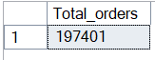

--Total Revenue(INR Millions)
SELECT
FORMAT(SUM(CONVERT(FLOAT, price_INR))/1000000, 'N2') + ' INR Million'
AS Total_Revenue
FROM fact_swiggy_orders
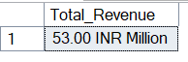
--Average Dish Price
SELECT
FORMAT(AVG(CONVERT(FLOAT, price_INR)), 'N2') + ' INR'
AS AVG_dish_price
FROM fact_swiggy_orders;
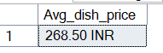
--Average Rating
SELECT AVG(Rating) AS Avg_Rating
FROM fact_swiggy_orders;
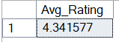

BUSINESS ANALYSIS
--Monthly Order TrENDs
SELECT
d.year,
d.month,
d.month_name,
COUNT(*) AS Total_orders
FROM fact_swiggy_orders f
JOIN dim_date d ON f.date_id = d.date_id
GROUP BY d.year,d.month,d.month_name
ORDER BY COUNT(*) DESC
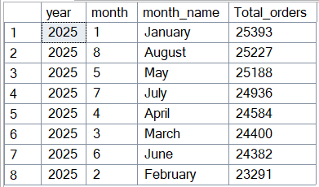
--Monthly Total Revenue TrENDs
SELECT
d.year,
d.month,
d.month_name,
FORMAT(SUM(CONVERT(FLOAT, price_INR))/1000000, 'N2') + ' INR Million'
AS Total_Revenue
FROM fact_swiggy_orders f
JOIN dim_date d ON f.date_id = d.date_id
GROUP BY d.year,d.month,d.month_name
ORDER BY SUM(price_INR) DESC;
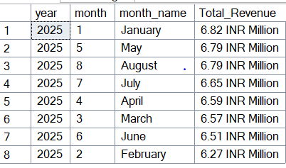

--Quarterly Order
SELECT
d.year,
d.quarter,
COUNT(*)
AS Quarterly_Orders
FROM fact_swiggy_orders f
JOIN dim_date d ON f.date_id = d.date_id
GROUP BY d.year, d.quarter;
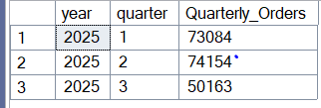
--Yearly TrEND
SELECT
d.year,
COUNT(*)
AS Yearly_Orders
FROM fact_swiggy_orders f
JOIN dim_date d ON f.date_id = d.date_id
GROUP BY d.year;
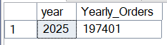

--Orders by day of week (Mon-Sun)
SELECT
DATENAME(WEEKDAY, d.Full_Date) AS day_name,
COUNT(*) AS total_orders
FROM fact_swiggy_orders f
JOIN dim_date d ON f.date_id = d.date_id
GROUP BY DATENAME(WEEKDAY, d.Full_Date), DATEPART(WEEKDAY, d.Full_Date)
ORDER BY DATEPART(WEEKDAY, d.Full_Date);
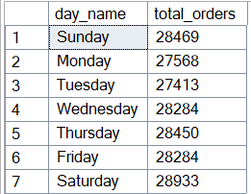

--Top 10 Cities by Order Volume
SELECT TOP 10
l.city,
COUNT(*) AS total_orders
FROM fact_swiggy_orders f
JOIN dim_location l
ON l.location_id = f.location_id
GROUP BY l.city
ORDER BY COUNT(*) DESC;
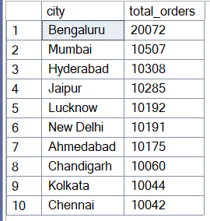
--Revenue Contribution By States
SELECT
l.state,
SUM(f.price_INR) AS total_revenue
FROM fact_swiggy_orders f
JOIN dim_location l
ON l.location_id = f.location_id
GROUP BY l.state
ORDER BY SUM(f.price_INR) DESC;
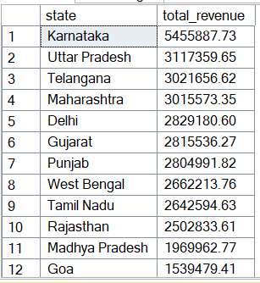

--Top 10 Restaurants by Orders
SELECT TOP 10
r.restaurant_name,
COUNT(*) AS total_orders
FROM fact_swiggy_orders f
JOIN dim_restaurant r
ON r.restaurant_id = f.restaurant_id
GROUP BY r.restaurant_name
ORDER BY COUNT(*) DESC;
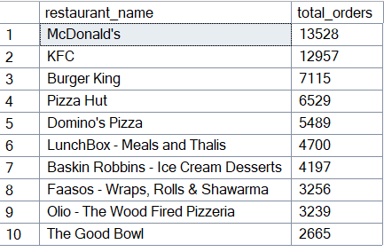
--Top Categories By Order Volume
SELECT
c.category,
COUNT(*) AS total_orders
FROM fact_swiggy_orders f
JOIN dim_category c ON f.category_id = c.category_id
GROUP BY c.category
ORDER BY total_orders DESC;
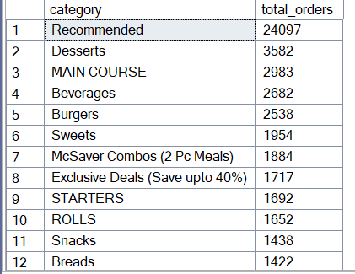
--Most Ordered Dishes
SELECT TOP 10
d.dish_name,
COUNT(*) AS total_COUNT
FROM fact_swiggy_orders f
JOIN dim_dish d ON f.dish_id = d.dish_id
GROUP BY d.dish_name
ORDER BY total_COUNT DESC;
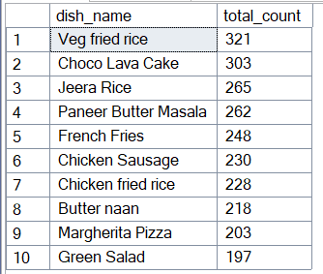
--Cuisine Performance (Orders + AVG Rating)
SELECT
c.category,
COUNT(*) AS total_orders,
AVG(f.rating) AS AVG_rating
FROM fact_swiggy_orders f
JOIN dim_category c ON f.category_id = c.category_id
GROUP BY c.category
ORDER BY total_orders DESC;
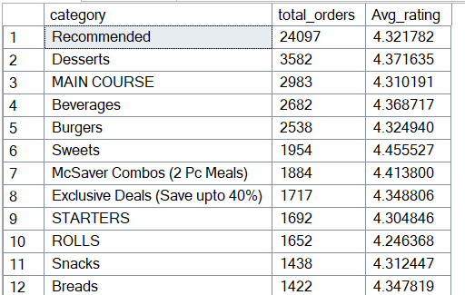
--Total Orders by Price Range
SELECT
CASE
WHEN CONVERT(FLOAT, price_INR) < 100 THEN ‘Under 100’
WHEN CONVERT(FLOAT, price_INR) BETWEEN 100 AND 199 THEN ‘100-199’
WHEN CONVERT(FLOAT, price_INR) BETWEEN 200 AND 299 THEN ‘200-299’
WHEN CONVERT(FLOAT, price_INR) BETWEEN 300 AND 499 THEN ‘300-499’
ELSE ‘500+’
END AS price_range,
COUNT(*) AS total_orders
FROM fact_swiggy_orders
GROUP BY
CASE
WHEN CONVERT(FLOAT, price_INR) < 100 THEN ‘Under 100’
WHEN CONVERT(FLOAT, price_INR) BETWEEN 100 AND 199 THEN ‘100-199’
WHEN CONVERT(FLOAT, price_INR) BETWEEN 200 AND 299 THEN ‘200-299’
WHEN CONVERT(FLOAT, price_INR) BETWEEN 300 AND 499 THEN ‘300-499’
ELSE ‘500+’
END
ORDER BY total_orders DESC;
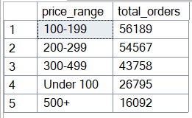

--Rating COUNT Distribution (1-5)
SELECT
rating,
COUNT(*) AS rating_COUNT
FROM fact_swiggy_orders
GROUP BY rating
ORDER BY COUNT(*) DESC;
